**Hop Box Construction**

Materials List:

HopBox:

* Sheet plastic for walls (⅛” thick)
  + Two pieces 11.25” x 16”
  + Two pieces 17.25” x 16”
* Eight pieces 90-degree 1” x 1” aluminum angle (1/16” thickness) cut to 15” long each
* Two pieces 90-degree 1” x 1” aluminum angle (1/16” thickness) cut to 11.5” long each
* 0.5” x 0.25” x 0.5” aluminum channel - two pieces 17.5” long and two pieces 11.5” long
* Galvanized sheet steel (26G; 12” x 18”)
* Hardware
  + Hinge with hardware
  + Handle with hardware
  + Eight wing nuts
  + Eight 1” long screws with 90 degree angles
* Double sided tape
* Matte white spray paint

Camera:

* DSLR Camera such as Canon EOS Rebel SL1
* Lens 18-55mm EF-S STM Lens
* Extra camera battery
* Camera battery charger
* SD card

Camera Mount:

* 90-degree aluminum angle 1.5” x 1.5” cut 5” long
* Aluminum channel 2” x 1” x 2” cut 8” long
* Aluminum channel 0.5” x 0.25” x 0.5” cut 5” long for handles (optional)
* Two 90-degree aluminum angles 1” x 1” cut 6” long
* Hardware:
  + 4 bolts 1” long
  + 2 bolts 3” long
  + 6 nuts
  + 4 flanges
* Wing knob nut with thread that fits the camera mount
* Magnetic tape
* Laboratory tape

Power Source and Lighting:

* 14.8V battery (Tenergy #31069 Li-Ion battery)
* Battery charger (Tenergy Smart Charger for 3.7-14.8V Li-Ion battery packs)
* On/off switch for power source/LED driver
* LDD H-4 driver board with spacers and screws (RapidLED)
* LDD-700H dimmable drivers (RapidLED)
* Rapid LED driver jumper (or other wire)
* Solderless LED plug (RapidLED)
* Solderless CREE XP-G3 Neutral White LED (RapidLED)
* Solderless LED to LED wire (RapidLED)
* Hot glue gun and glue
* Aluminum foil
* Duct tape

Interior Materials:

* Scale - ideally with a large pan size to accommodate baking sheet (Ohaus Scout STX2201)
* Sample pan (Chicago Metallic Bakeware, 9.5”x13”, 16 gauge, glazed aluminum)
* Laboratory tape
* Barcode labels with QR codes
* Colorchecker classic card (X-Rite; Grand Rapids, MI, USA)

Data Collection (for recording image weights):

* Barcode scanner
* Computer
* “Print” function enabled on balance to communicate weights to computer

Recommended Tools:

* Drill
* Bit set
* Clamps
* Circular saw
* Hackzall with metal blades
* Metal snips
* Wrench set
* Hole dozer set
* Phillips screwdriver
* Square
* Measuring tape
* Sharpie

Instructions:

*Camera Mount*

Step 1: Cut aluminum angles to size.

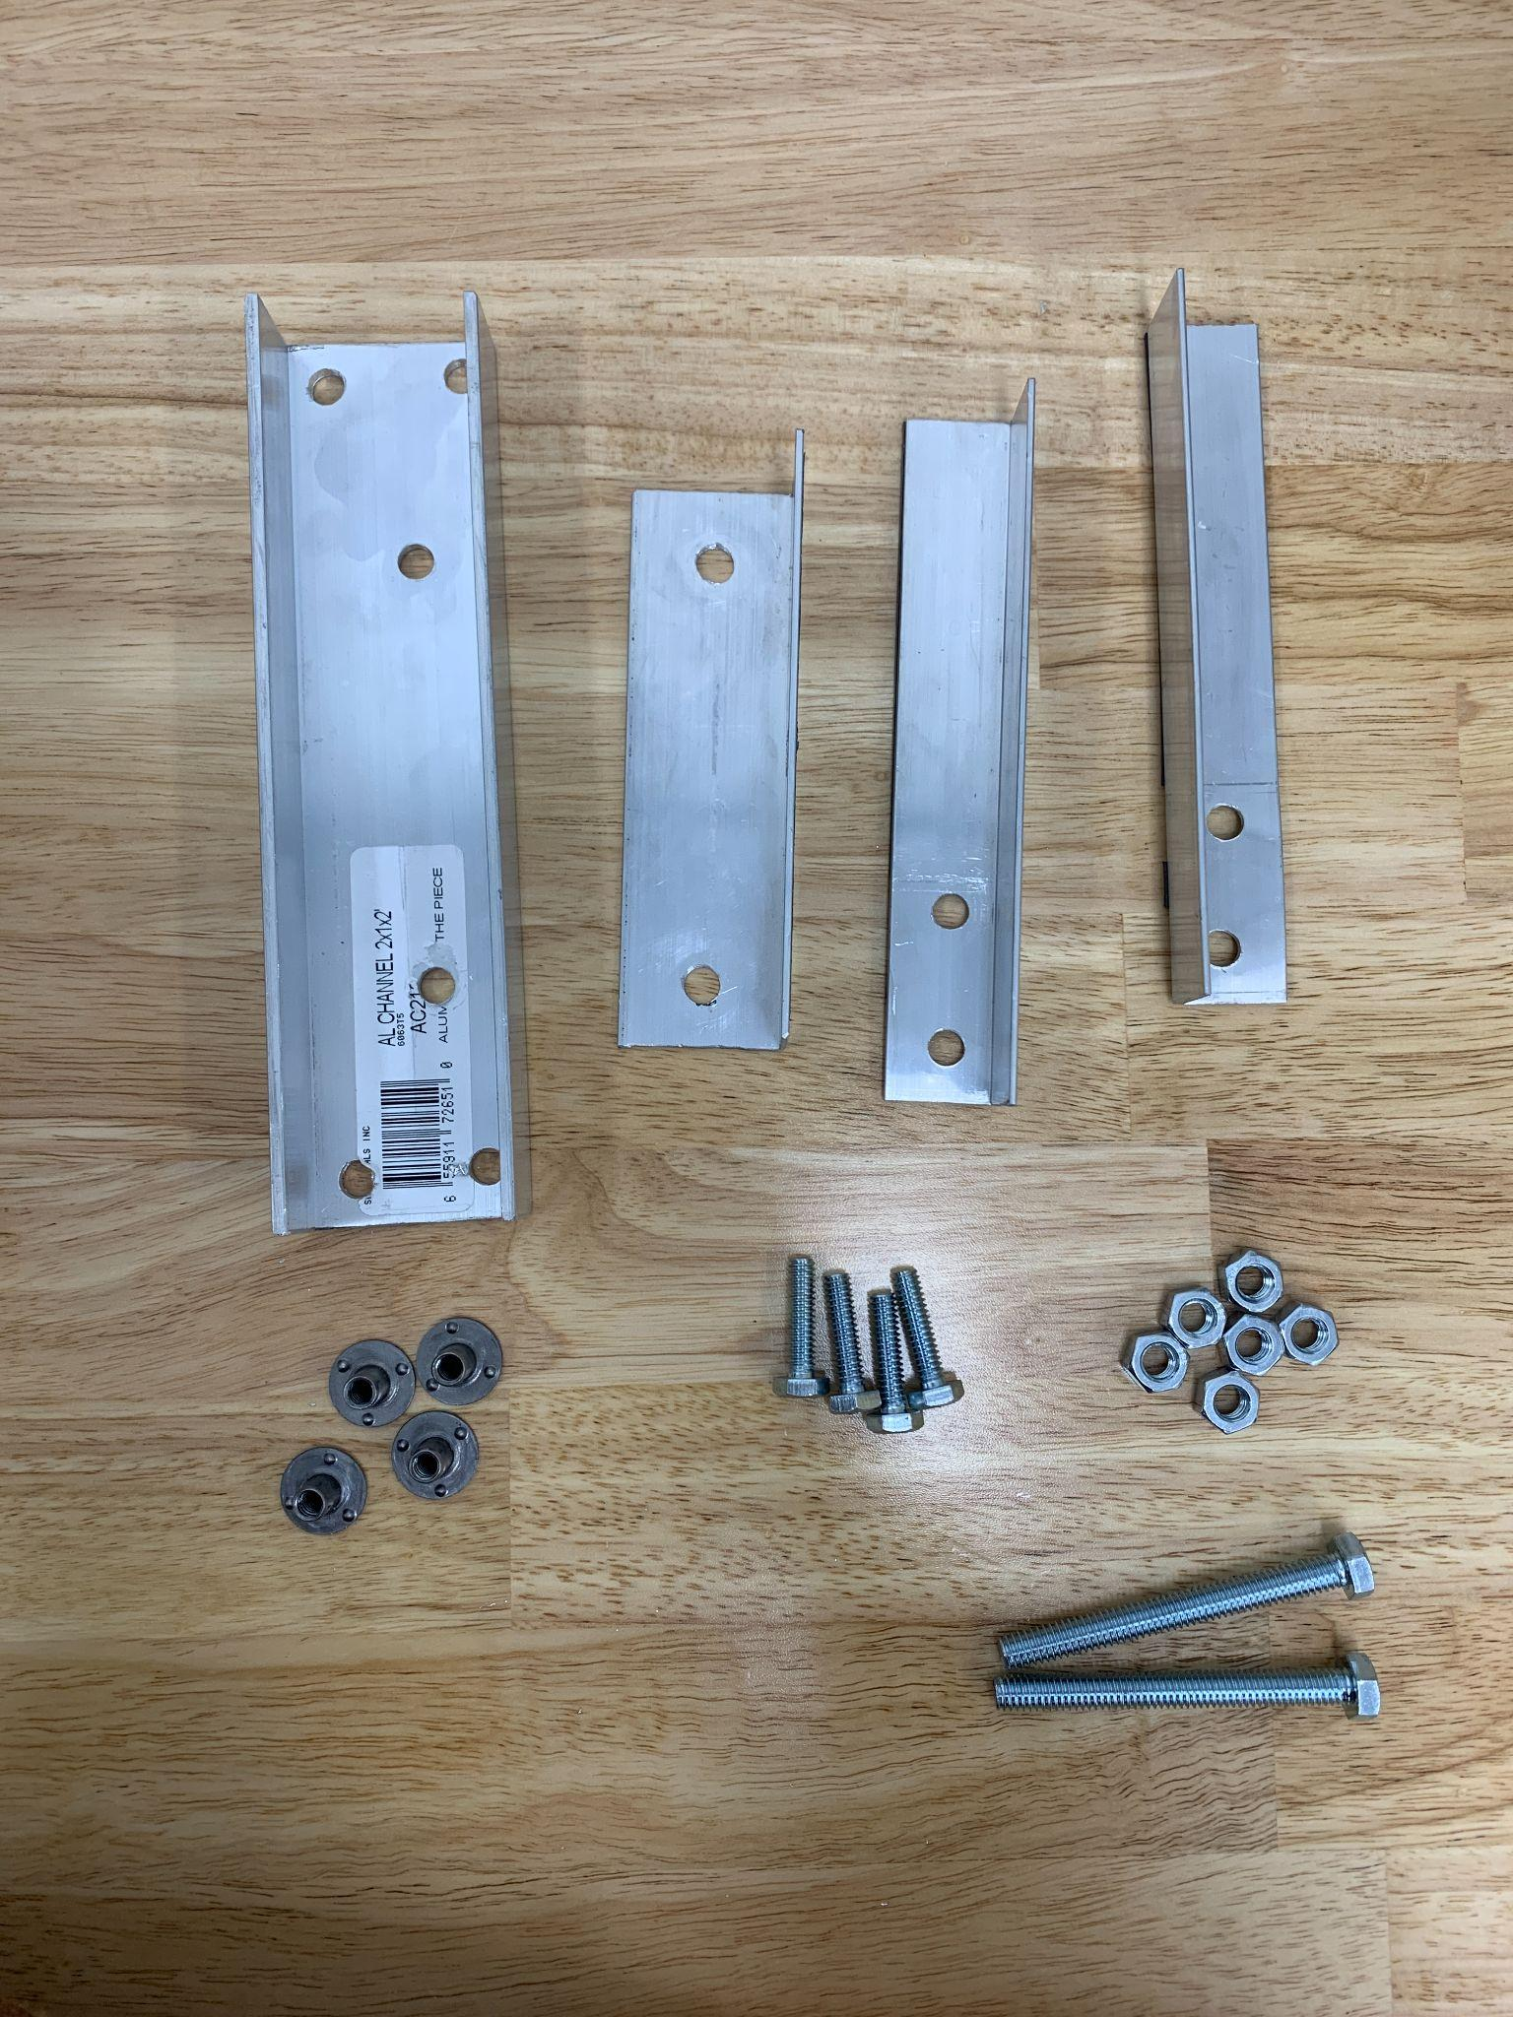

Step 2: Dry fit pieces, clamp into place. Measure and drill holes appropriately sized for the bolts.

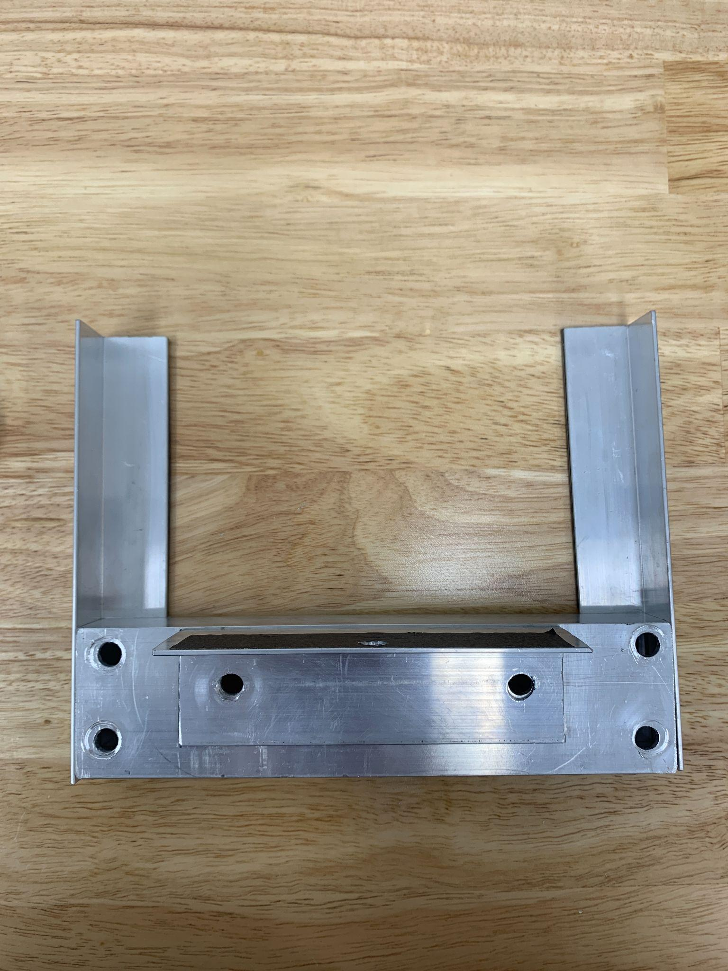

Step 3: Assemble with hardware.

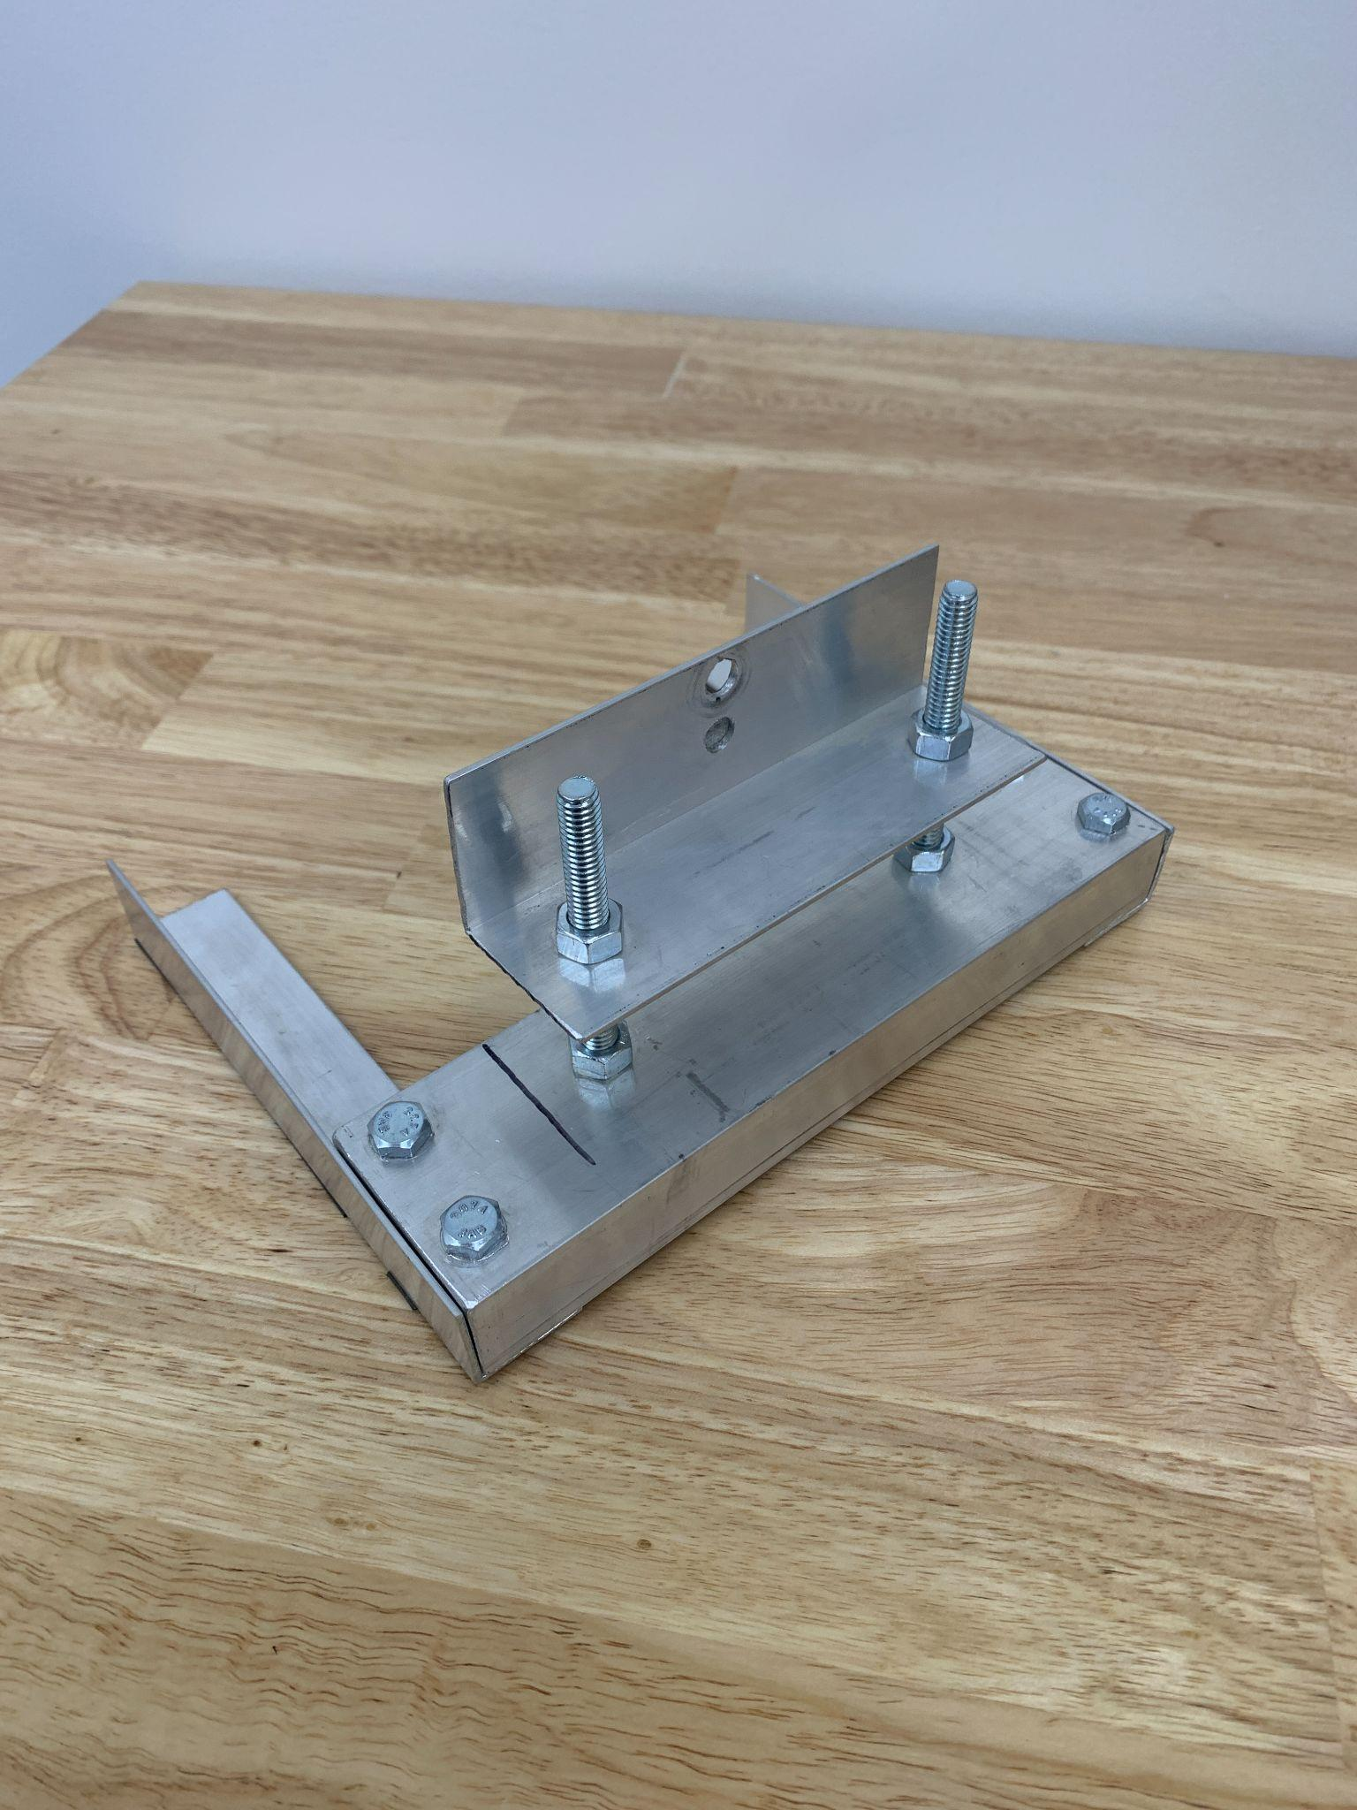

Step 4: Affix magnetic tape on the underside of the mount. Affix lab tape where the underside of the camera goes to prevent scratching.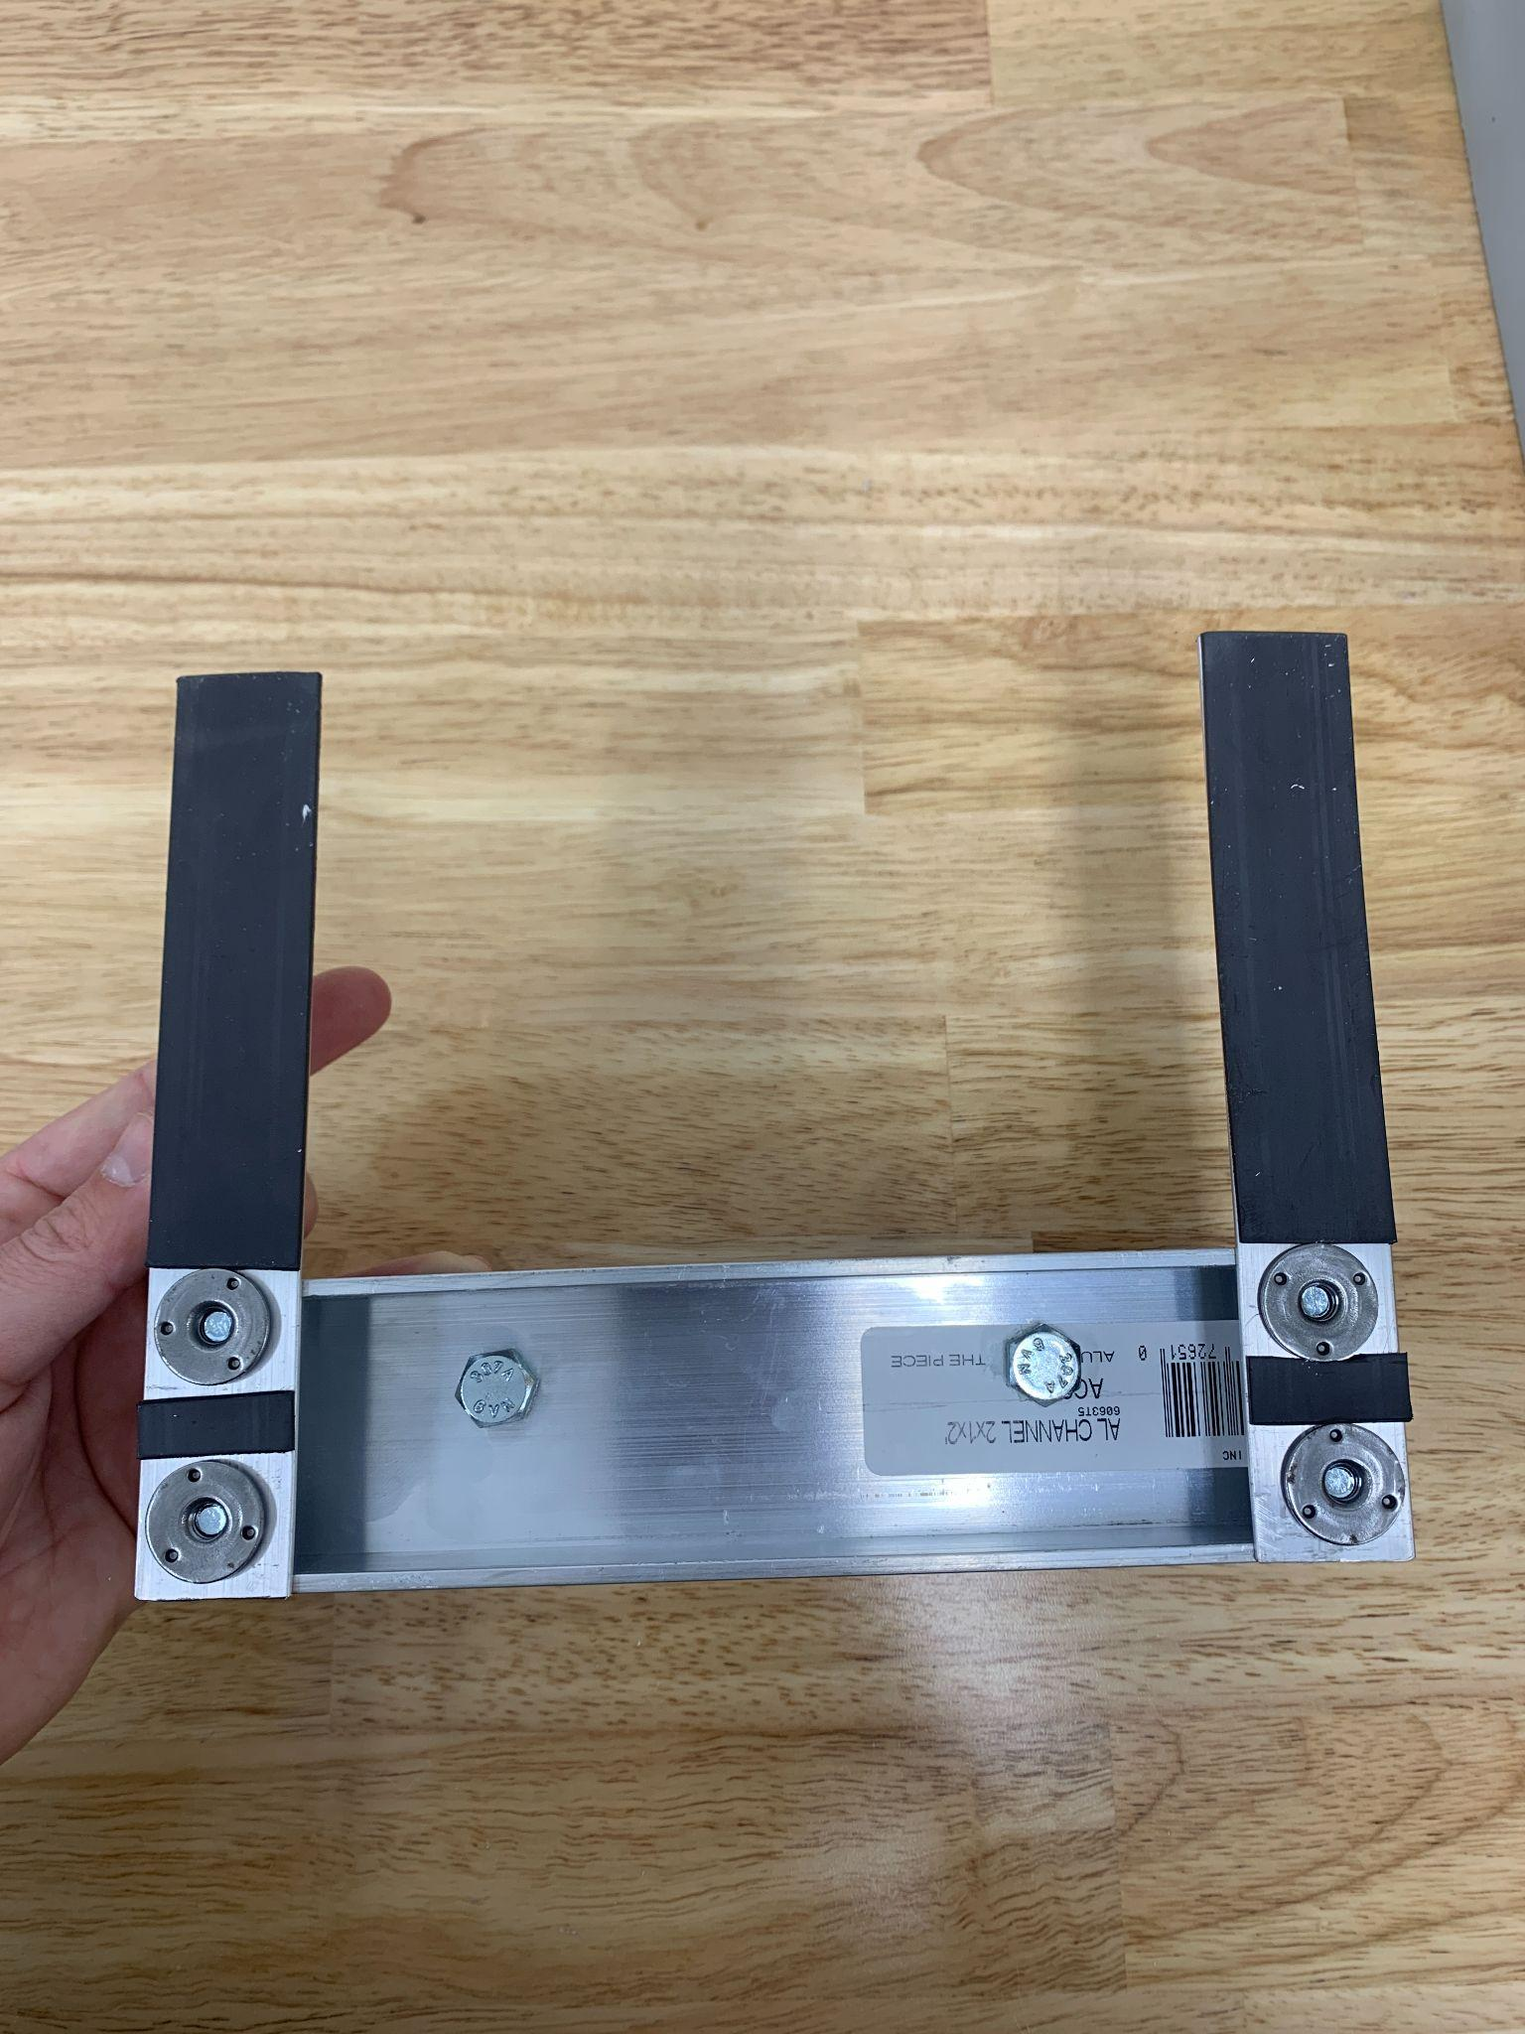

*HopBox:*

Step 1: Cut plastic wall pieces according to materials instructions. Cut a door in the front panel (14” x 9.5”). Attach hinge and handle. Hot glue handles on sides. Cut 1” diameter hole in back panel for balance cord. Add small 2.5” long wood pieces using a hot glue gun (optional) to serve as guides for the imaging plate.

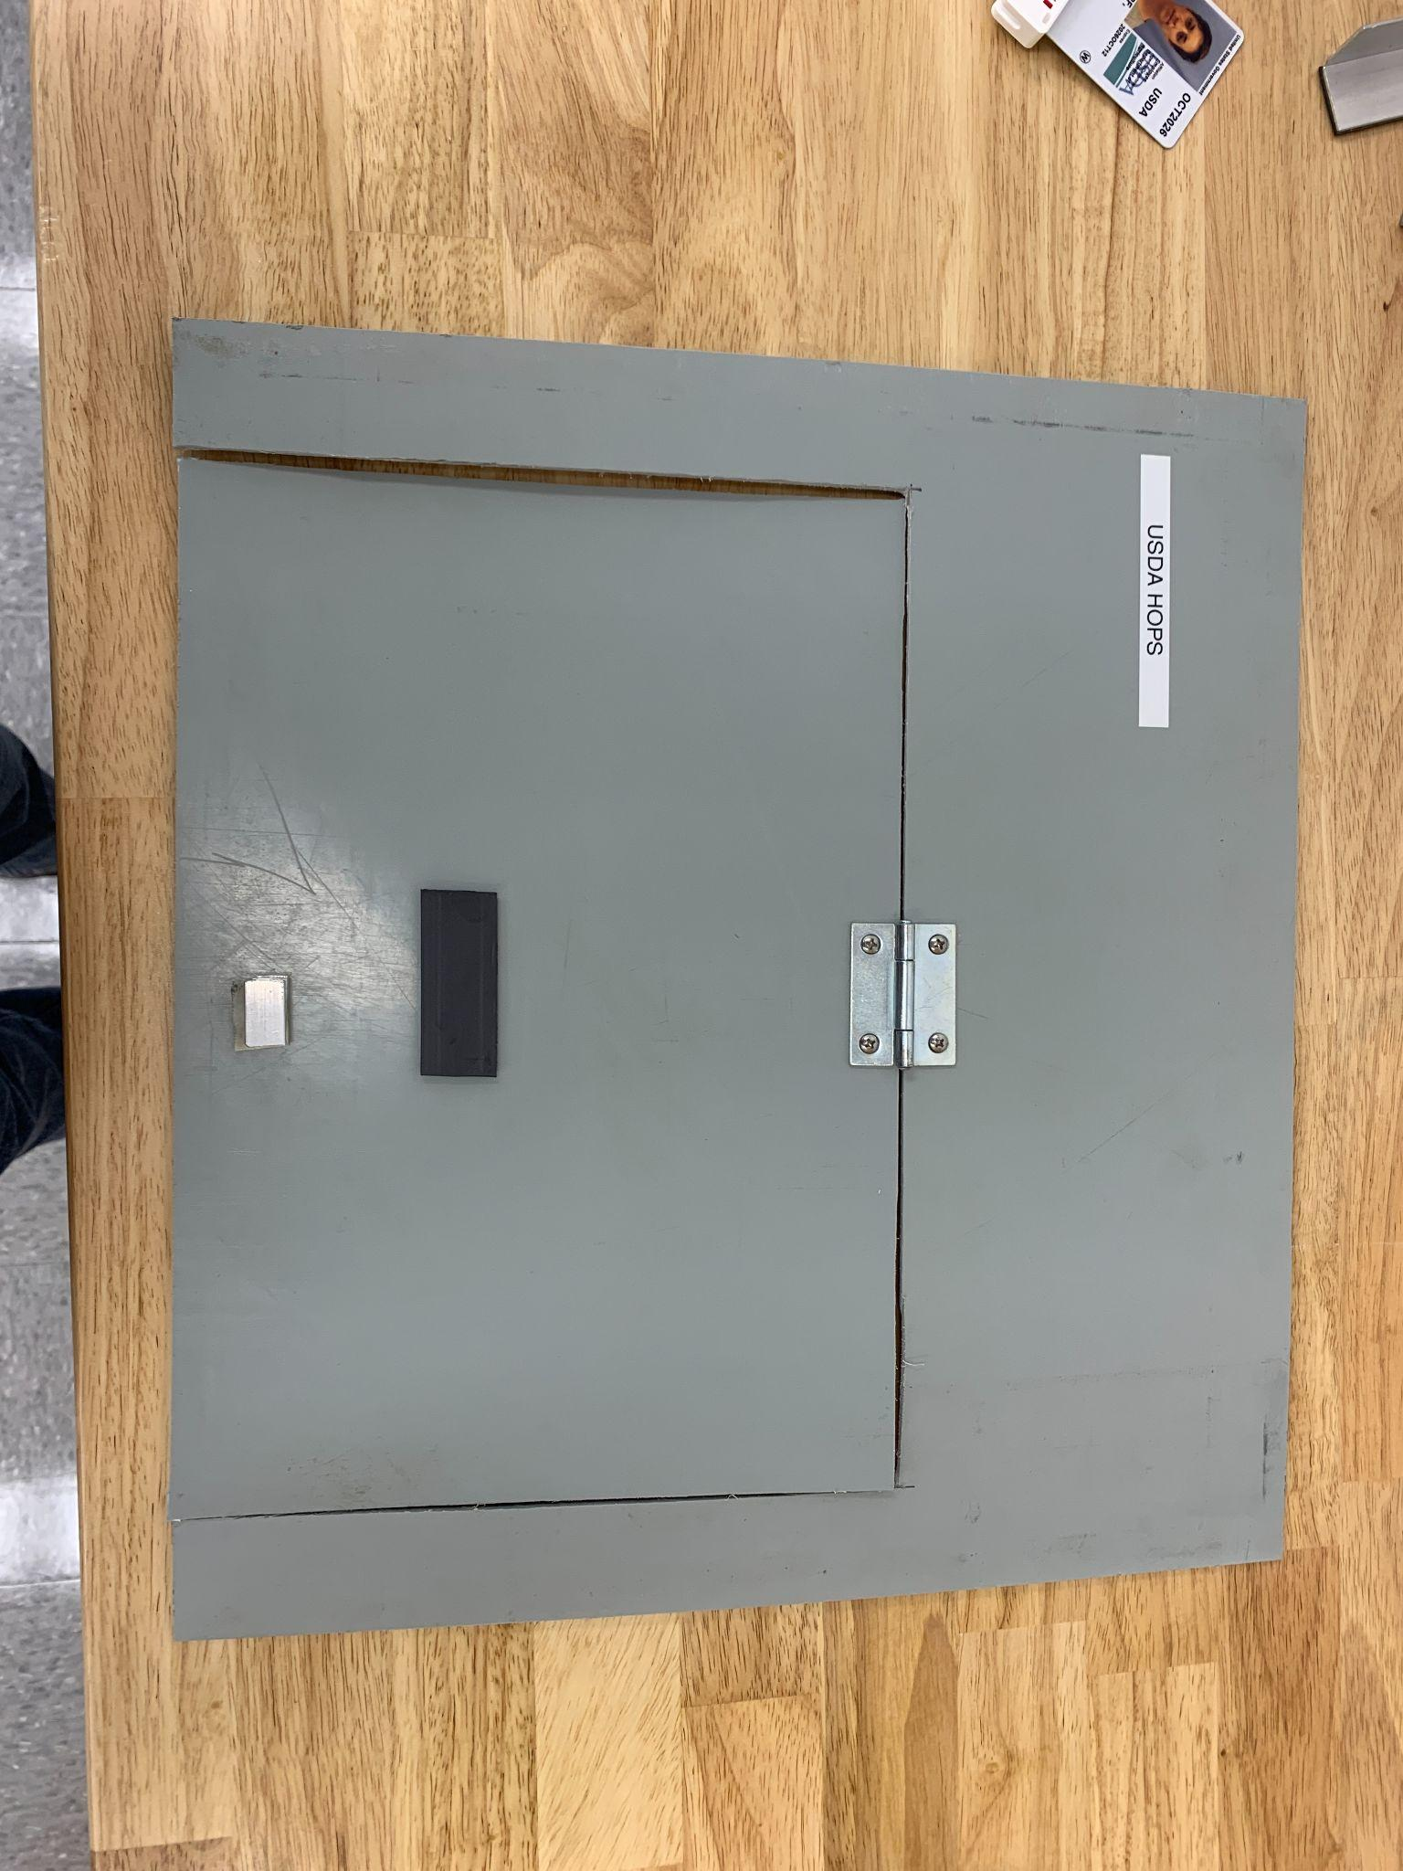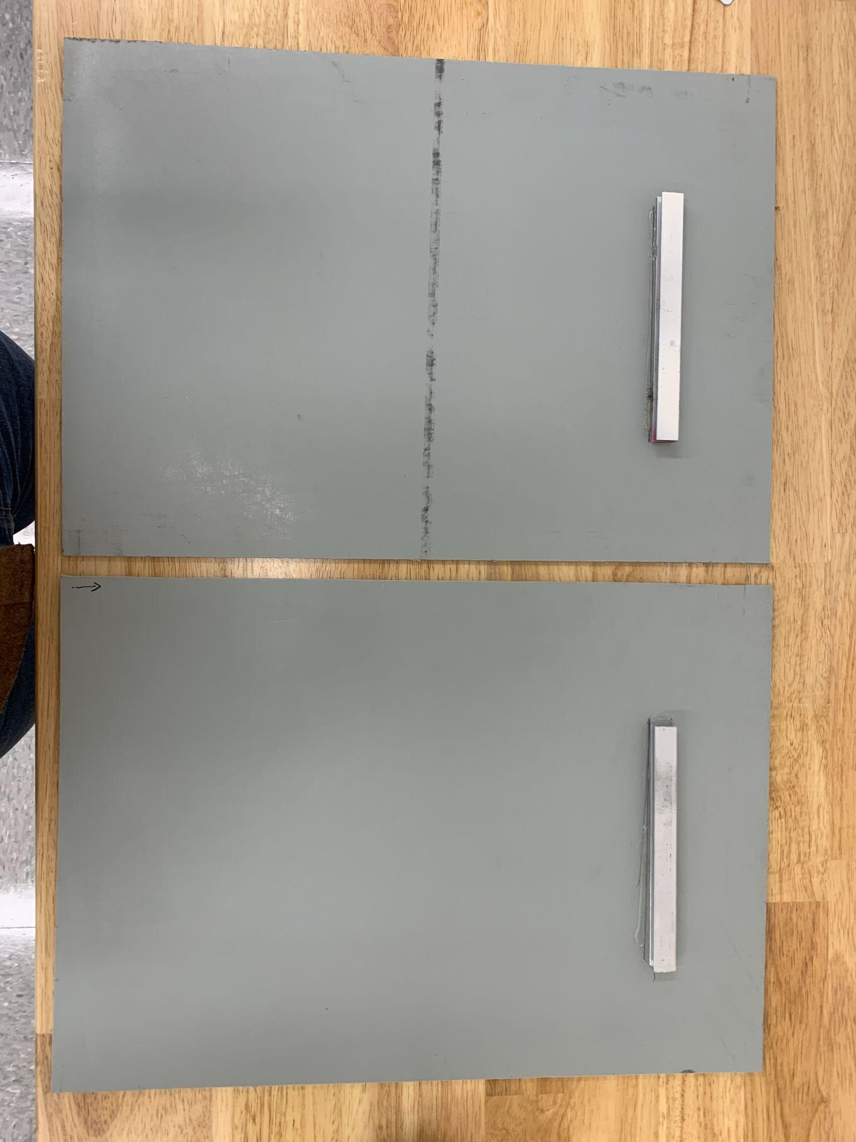

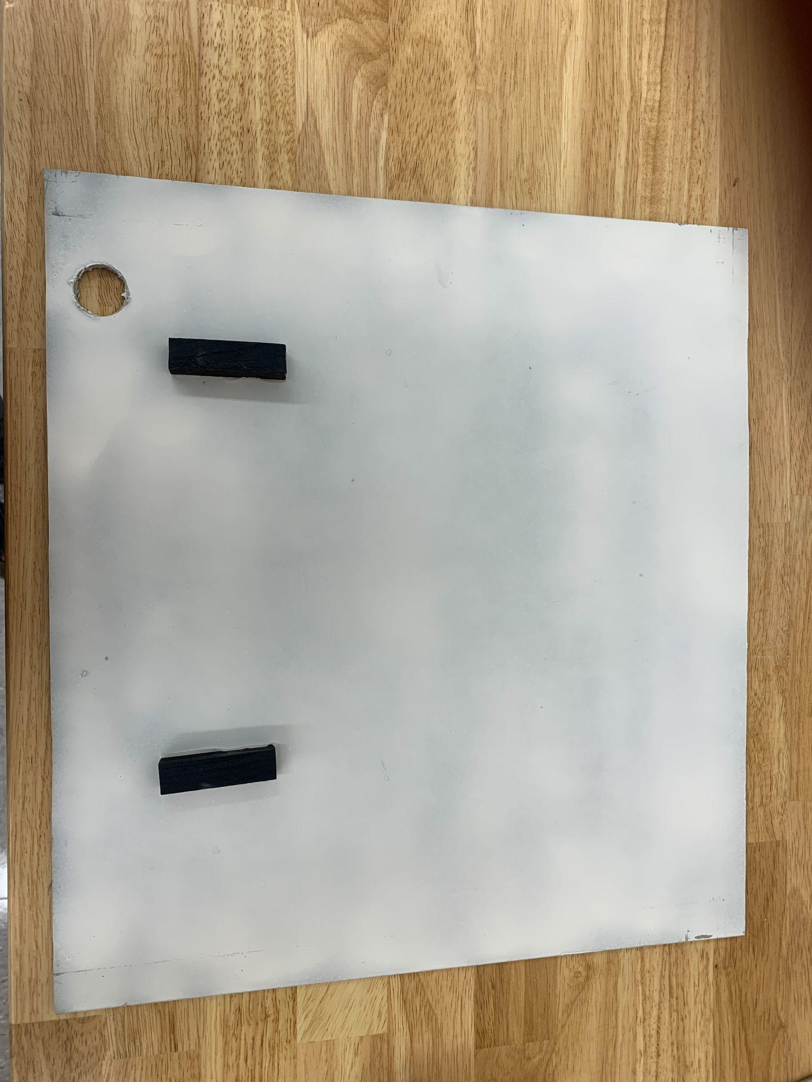

Step 2: Cut angled aluminum to length. Align pieces, clamp down, and drill holes appropriately sized for the screws approximately 1.5” from the edges taking care to make sure the holes align. 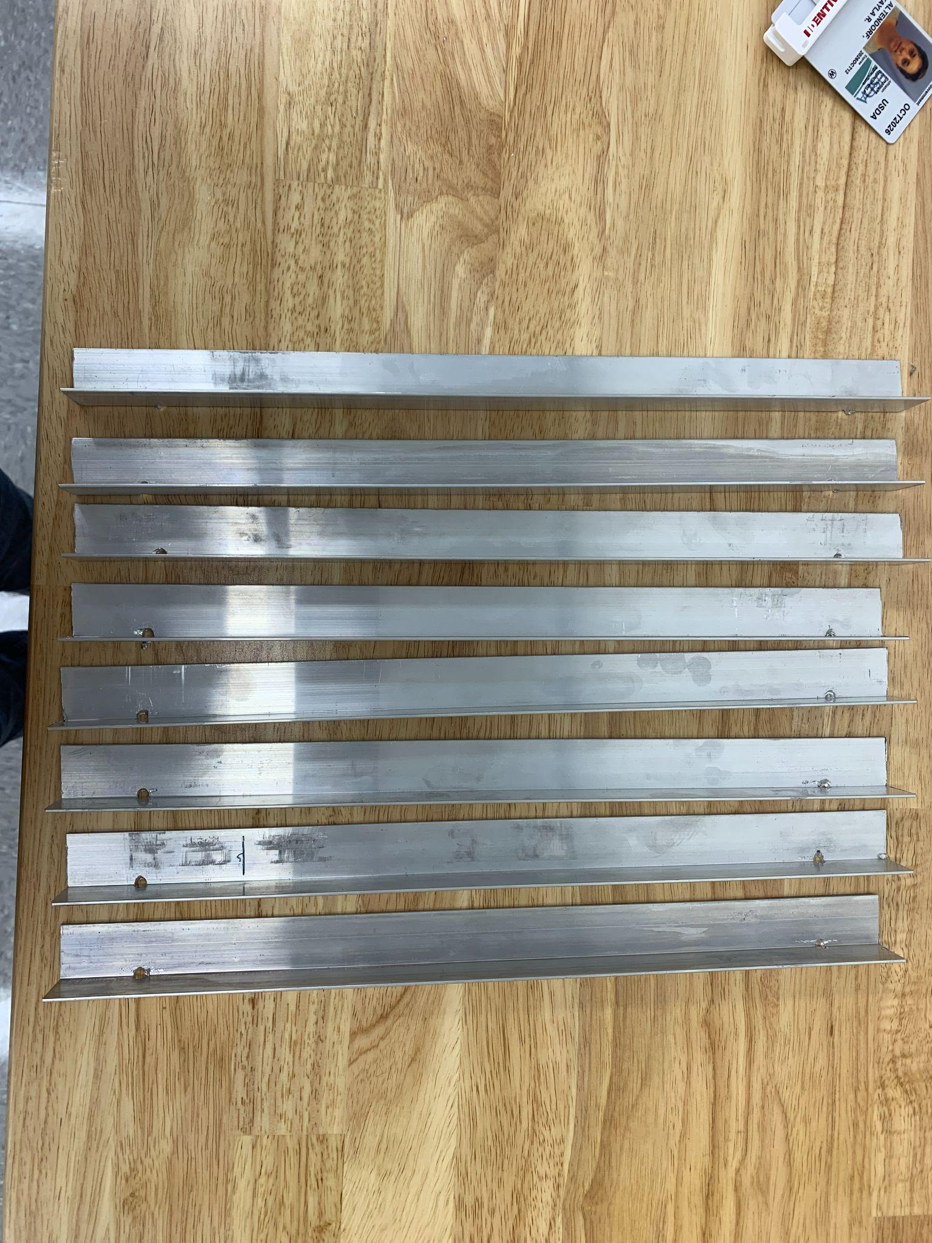

Step 3: Sandwich plastic walls between aluminum angles and secure tightly with screws and wing nuts. Place aluminum angles as low on the walls as possible to allow space for the top panel to sit on top of the exposed plastic. Spray paint the interior of the HopBox walls matte white.

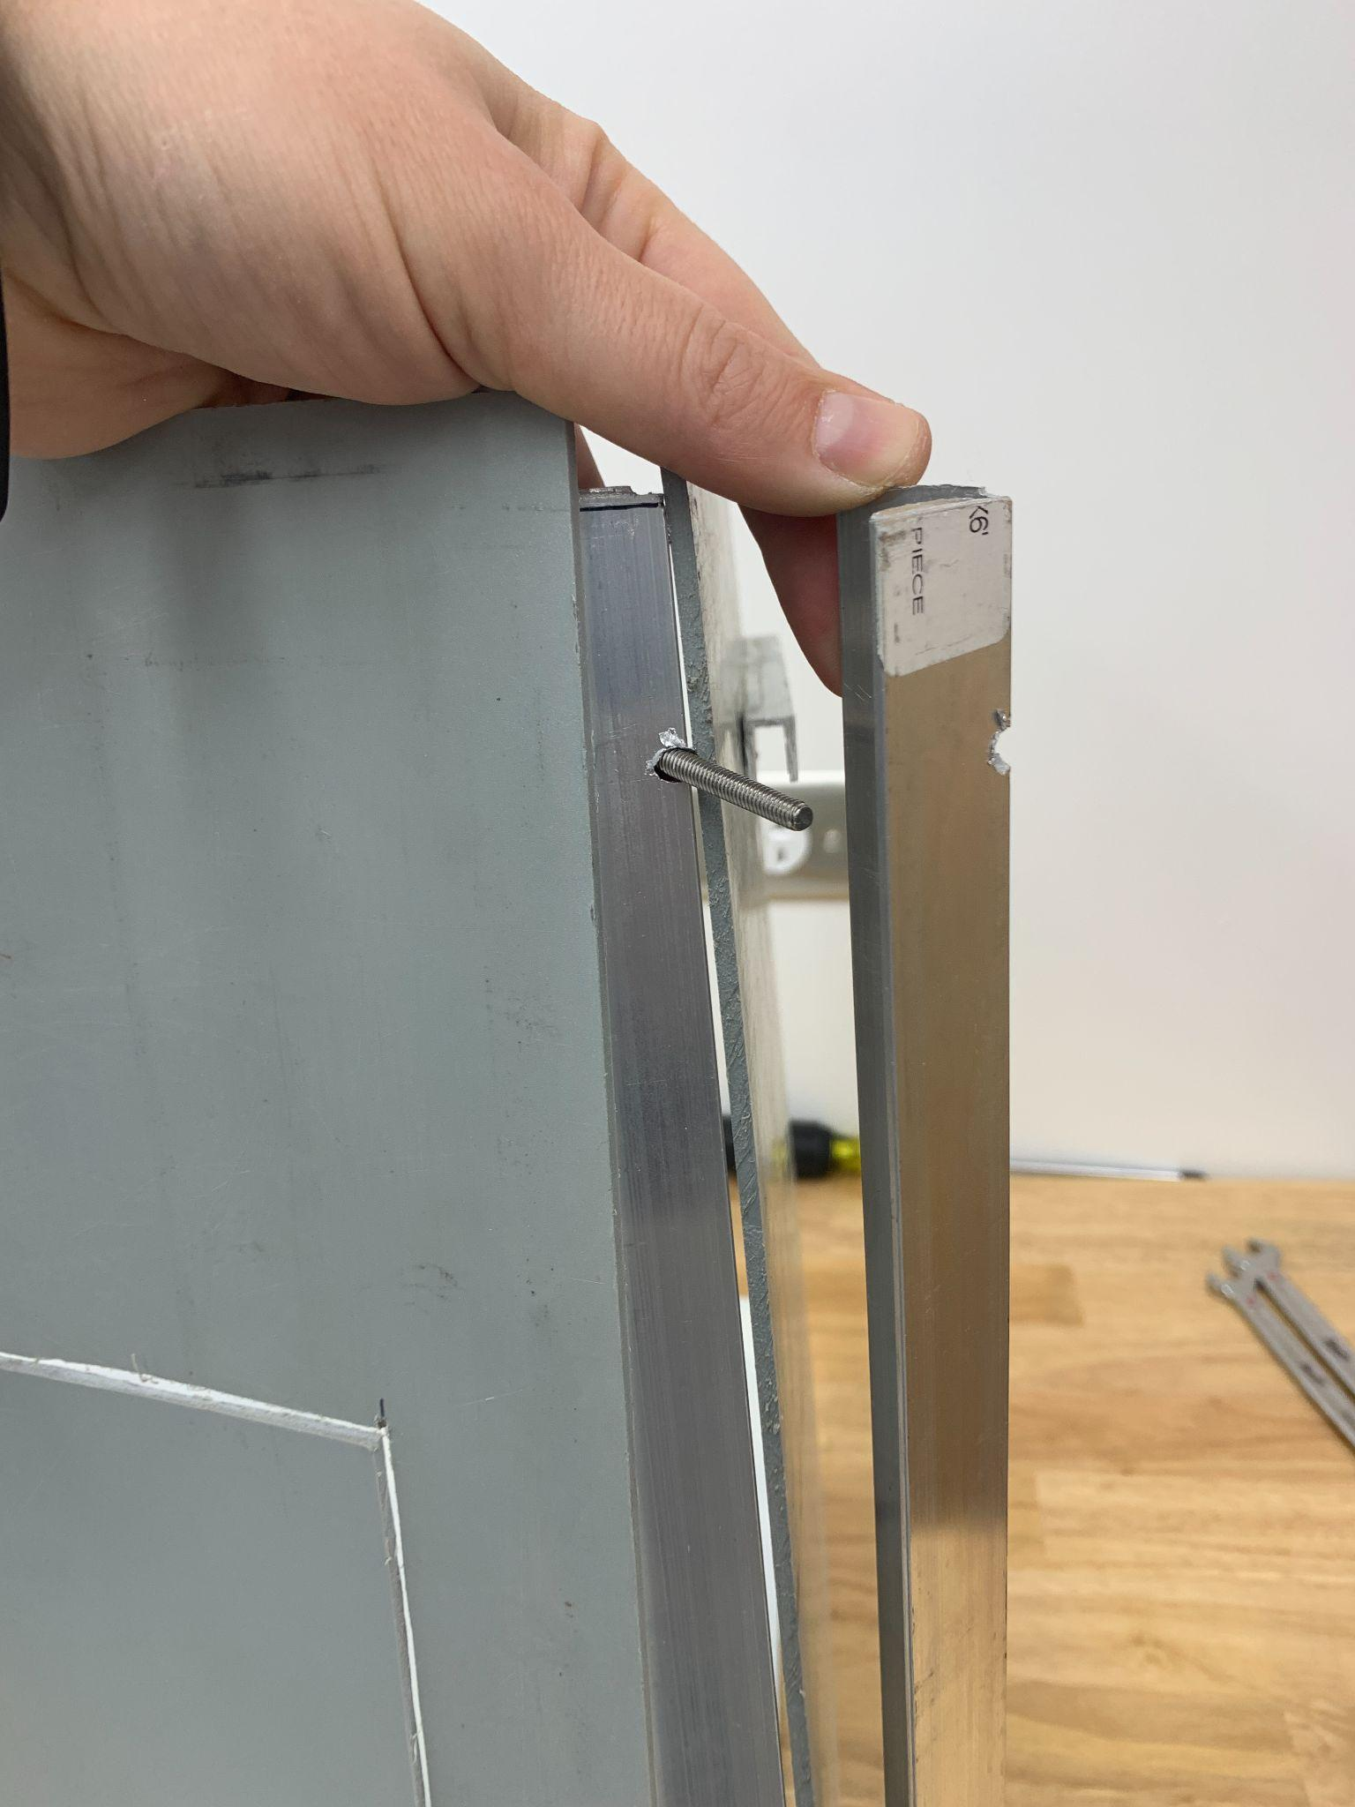

Step 4: Prepare the top panel. Cut a 3” diameter hole using metal snips in the center (7.5” from sides, 4.5” from top and bottom) of the 12” x 16” platinum metal sheet. Cover with duct tape to protect sharp edges. Cut aluminum channel and affix to edges of platinum metal sheet using double sided tape.

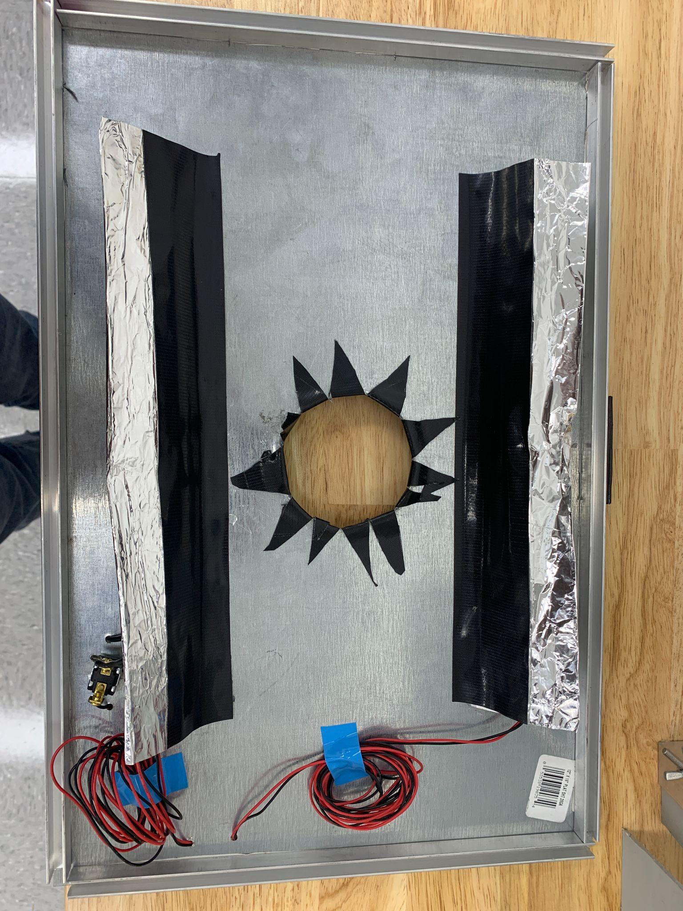

Step 5. Affix 1” aluminum angles on either side of the cut hole using hot glue. Fold several pieces of aluminum foil the same length as the aluminum angles and affix to the insides using duct tape. This is to help reflect the light around inside the box. Affix 3 Solderless CREE XP-G3 Neutral White LED lights approximately 4.5” apart using double sided tape along each of the aluminum angles. Connect using solderless LED wire. Attach a solderless LED plug to the last LED on each side. Drill small holes for on/off switch and to fish solderless LED wires to the top of the metal. Connect and affix 14.8V Tenergy battery, LED drivers and LED driver board to the top so that they do not interfere with the camera mount. In order to connect the LEDs to the switch and batteries, attach the positive and negative LED wires to the LED outputs on the driver board. Connect the negative battery wire to the switch and the positive wire to the DC input on the LED driver board. Cut a separate, short wire to affix the switch to the DC output on the LED driver board. Place laboratory tape around the camera mount to ensure similar positioning during each use.

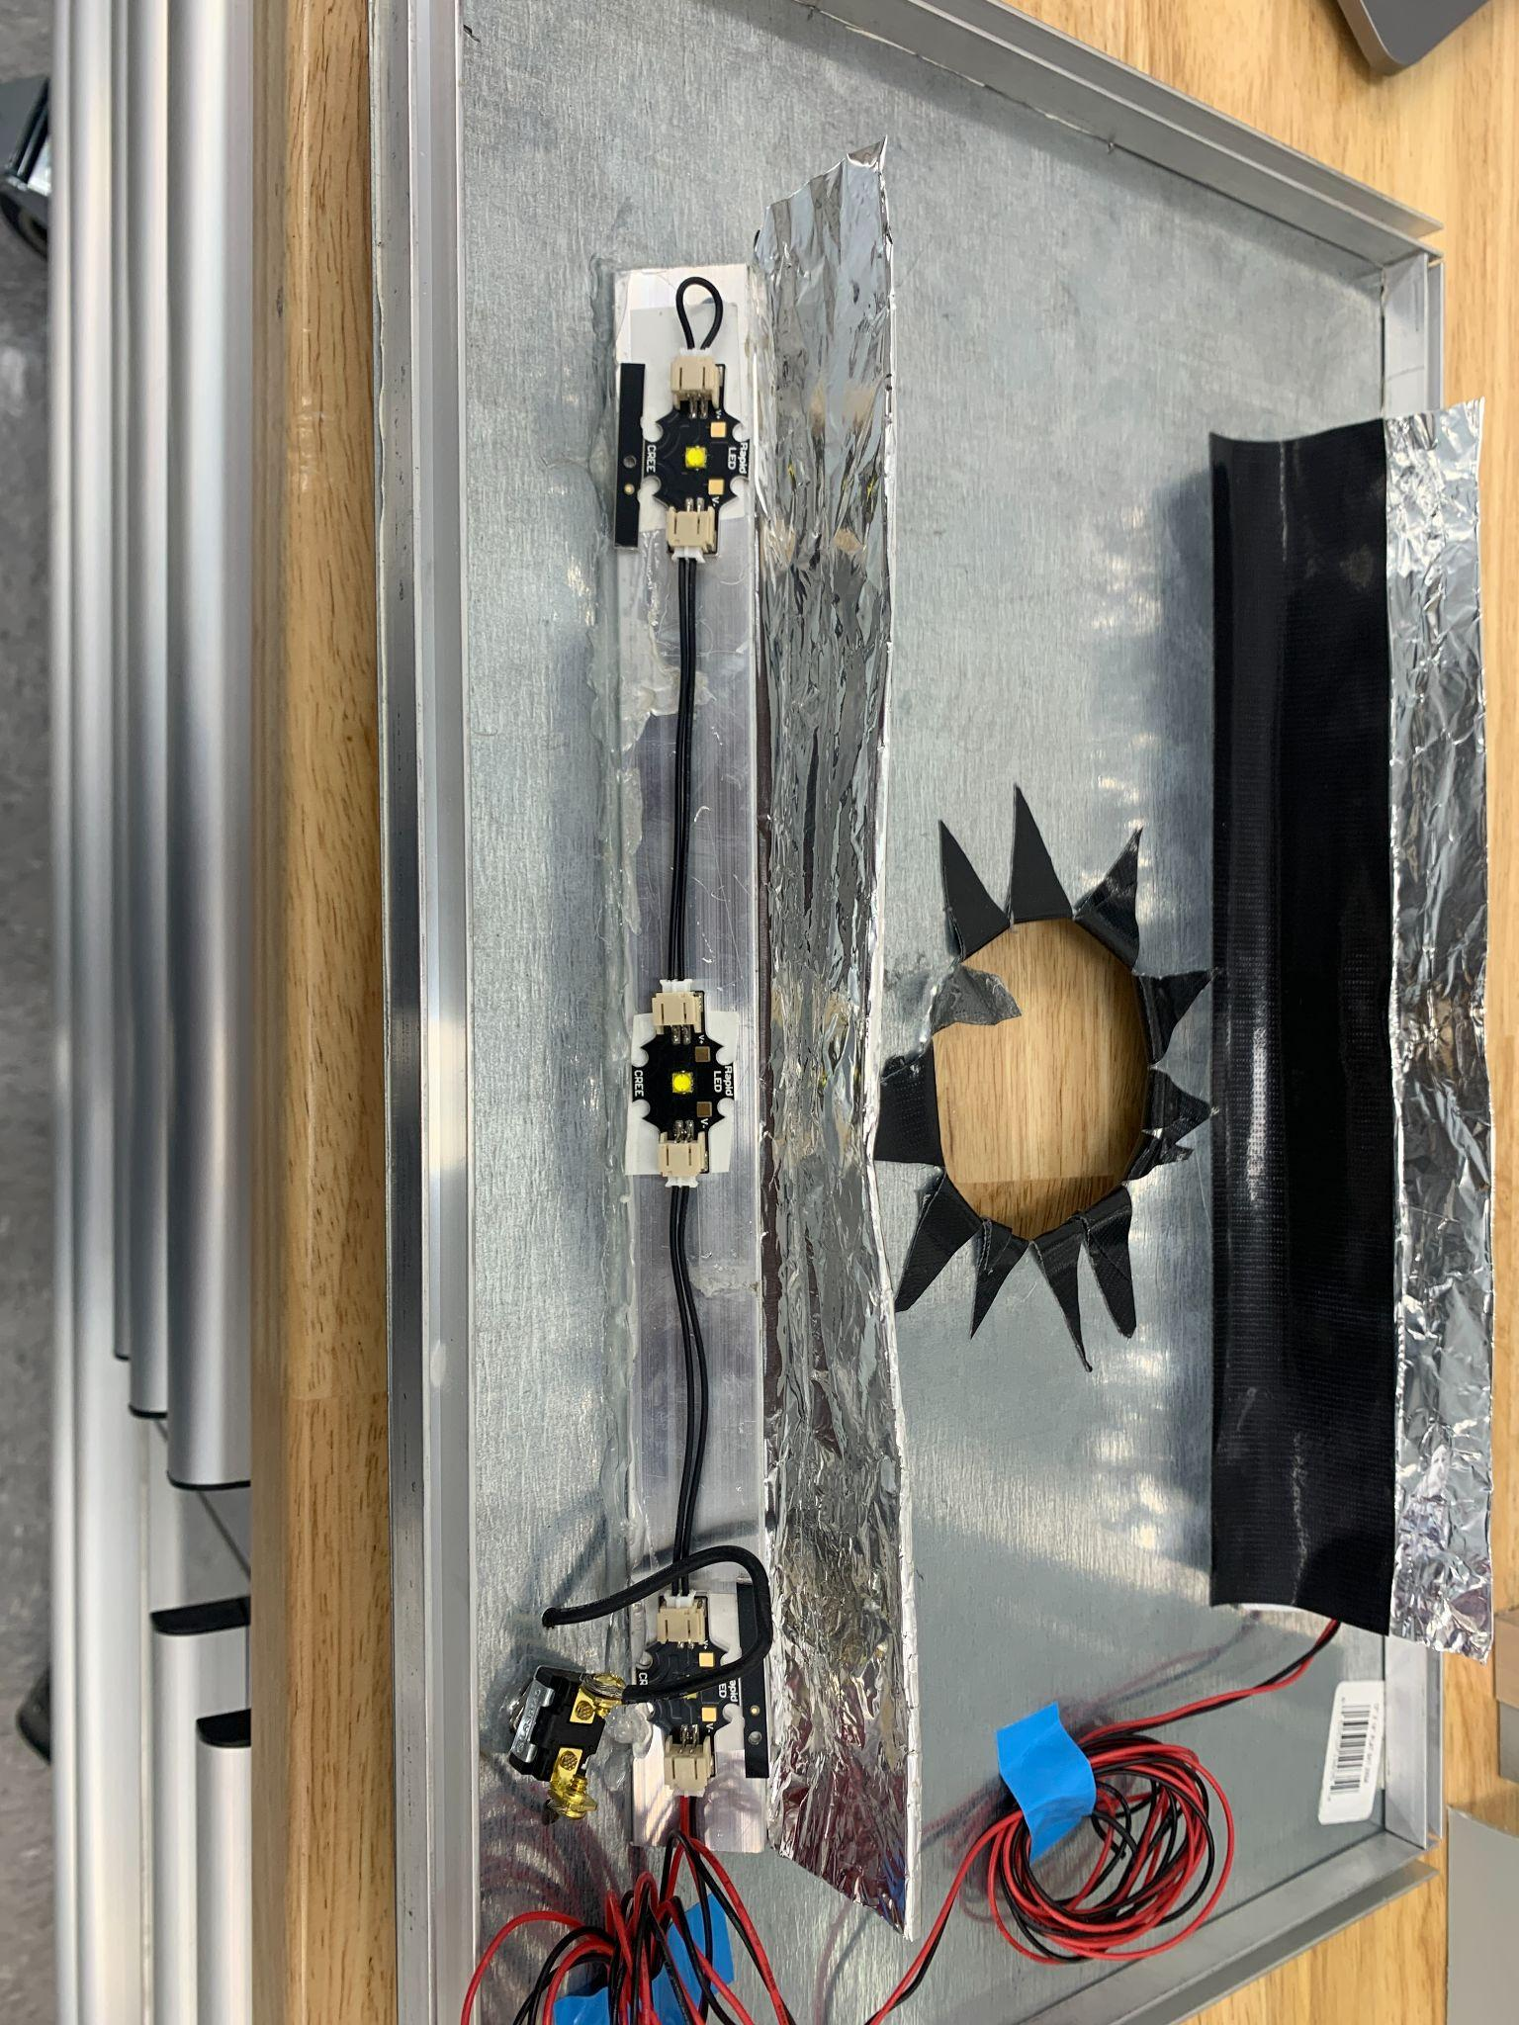

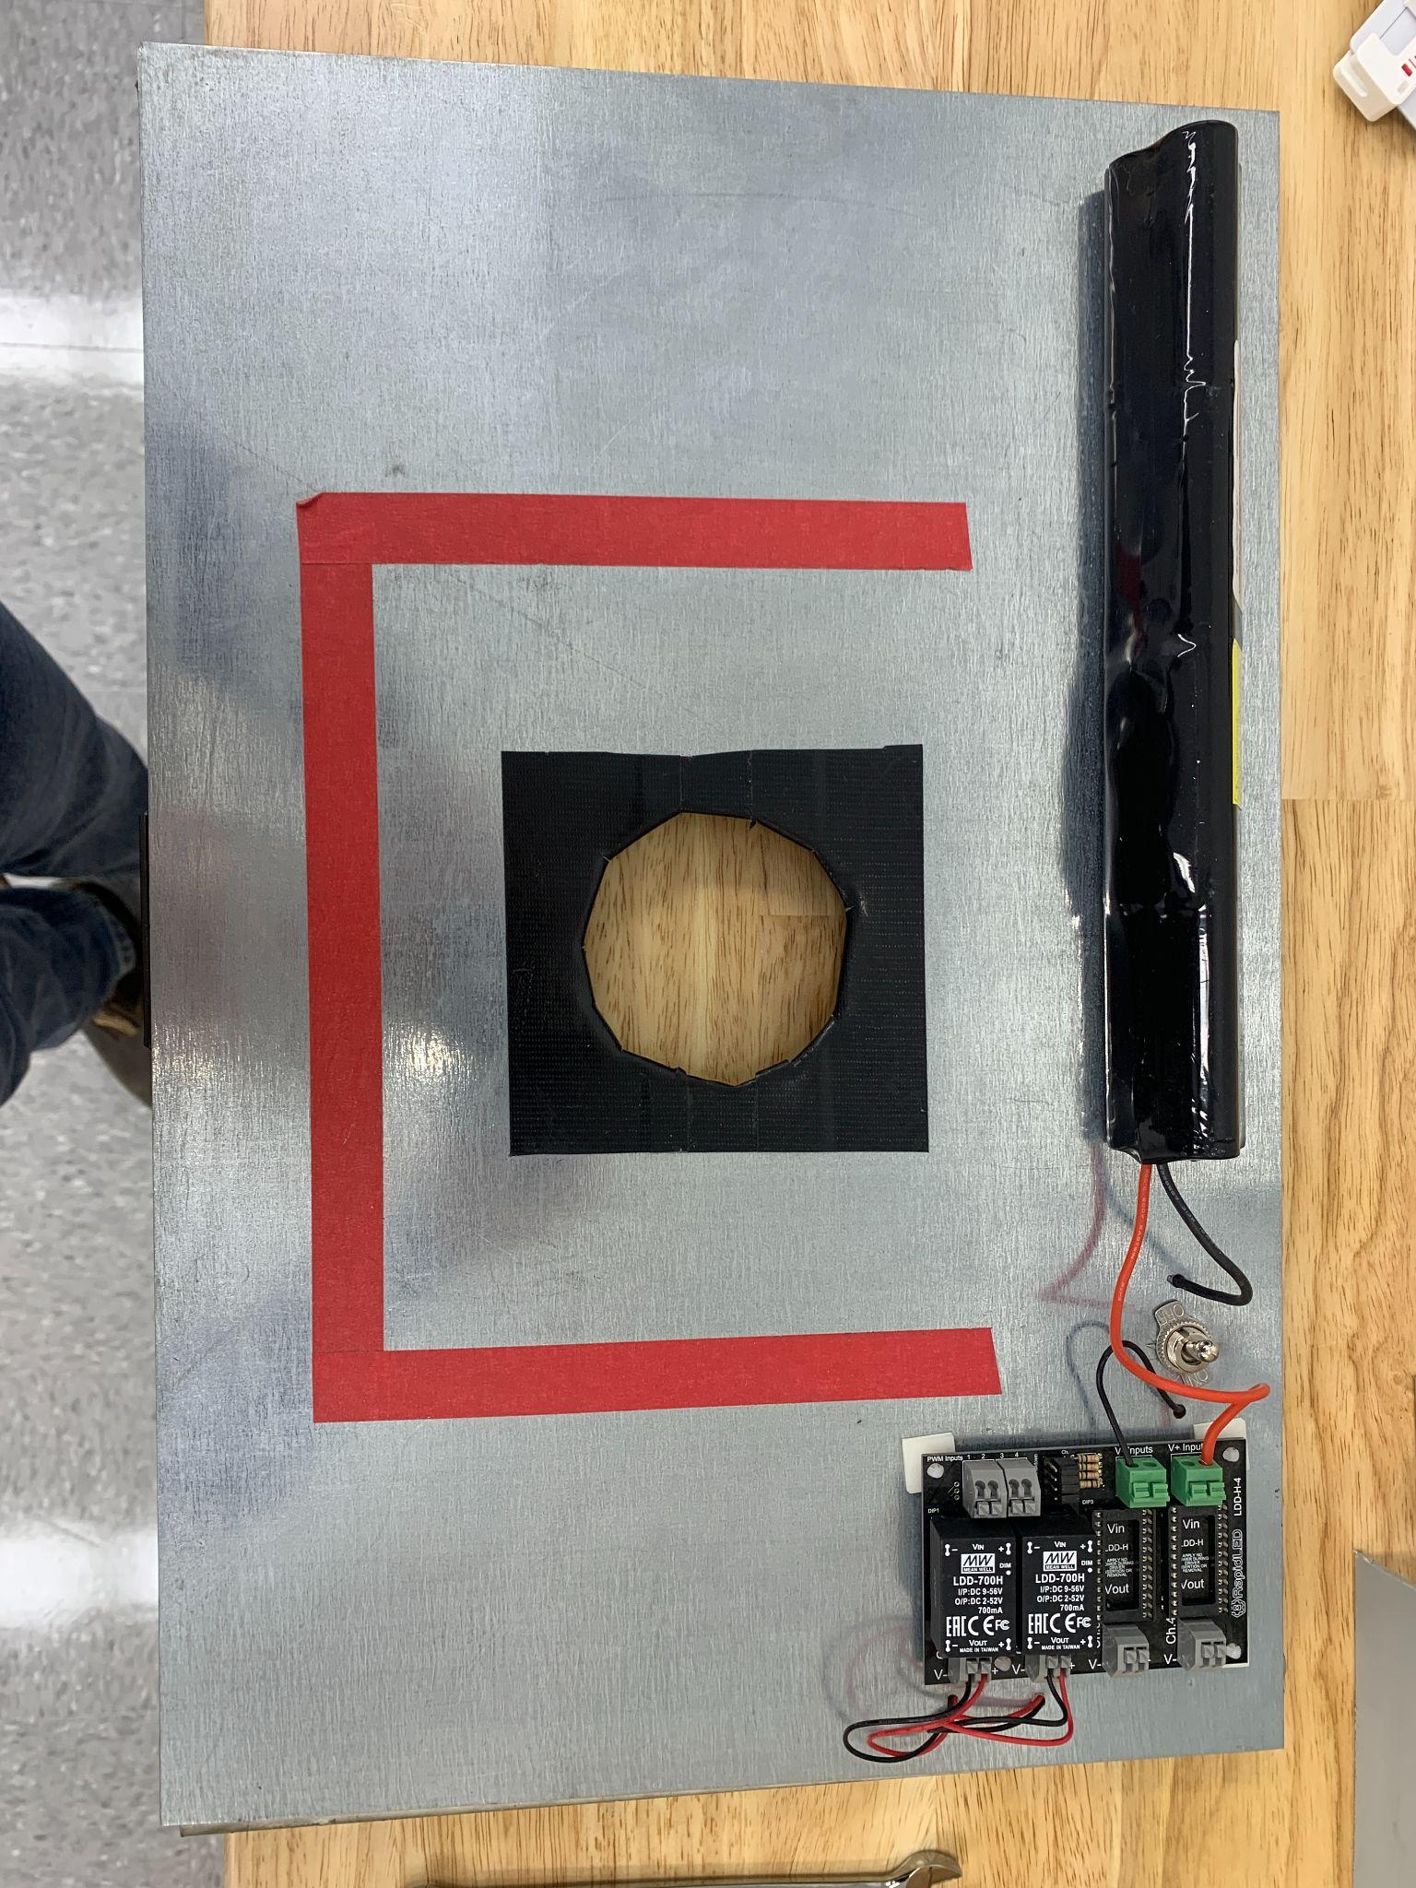

Step 6: Attach camera to mount using wing knob nut. Add an additional magnetic strip to allow the door to stay open. Prepare the sample pan by affixing the color card, and designating a location for the QR tag. Place balance and pan inside HopBox. Tare the balance with the pan when collecting image weights.

